Chapter 7

Memory Organization

- Memory Hierarchy
- Memory Interfacing diagram (RAM and ROM with 8085)
- Associative Memory
- Cache Memory and mapping techniques

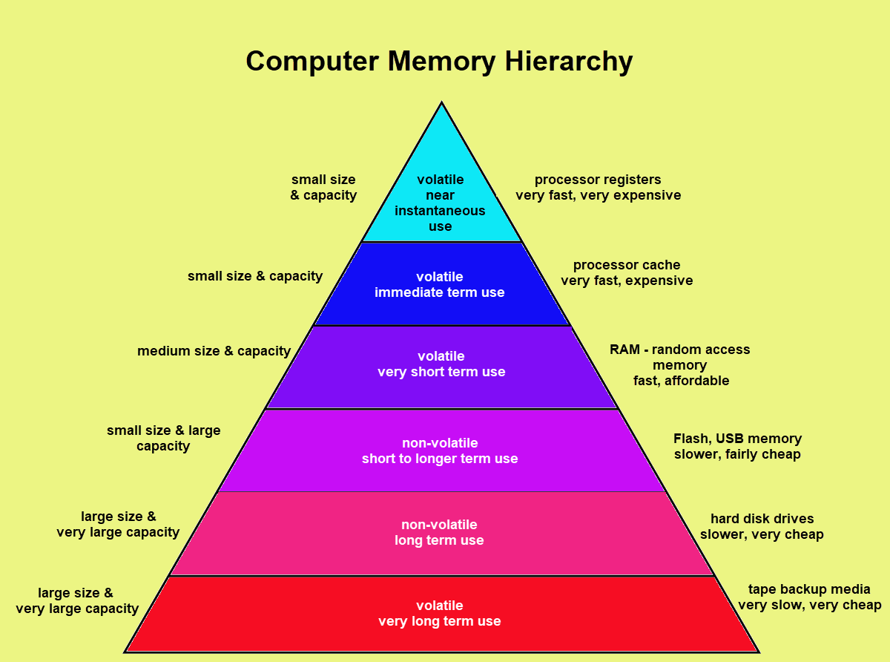
Memory Hierarchy

Memory interfacing diagram (RAM and ROM with 8085)

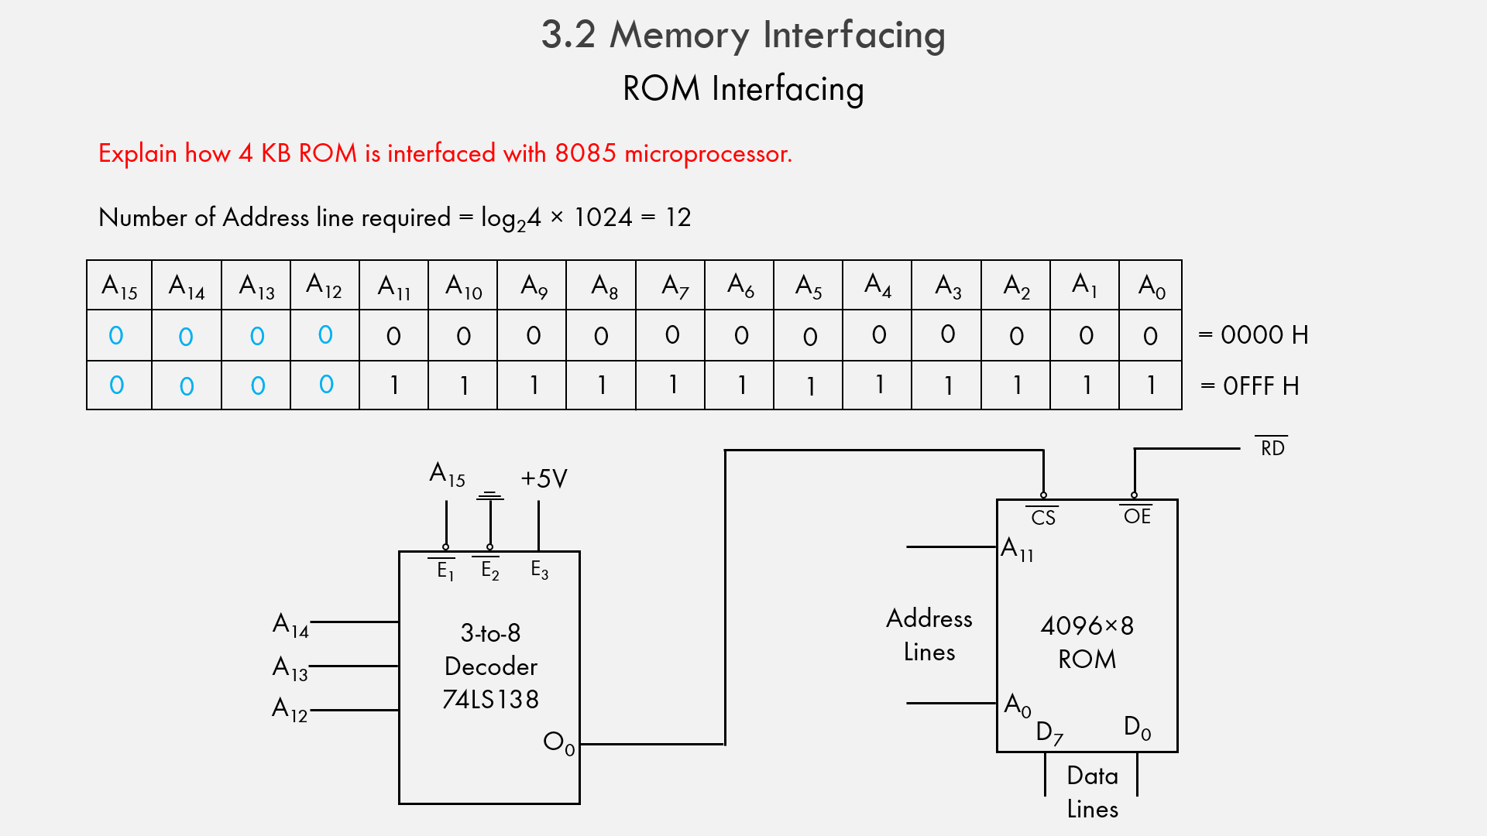

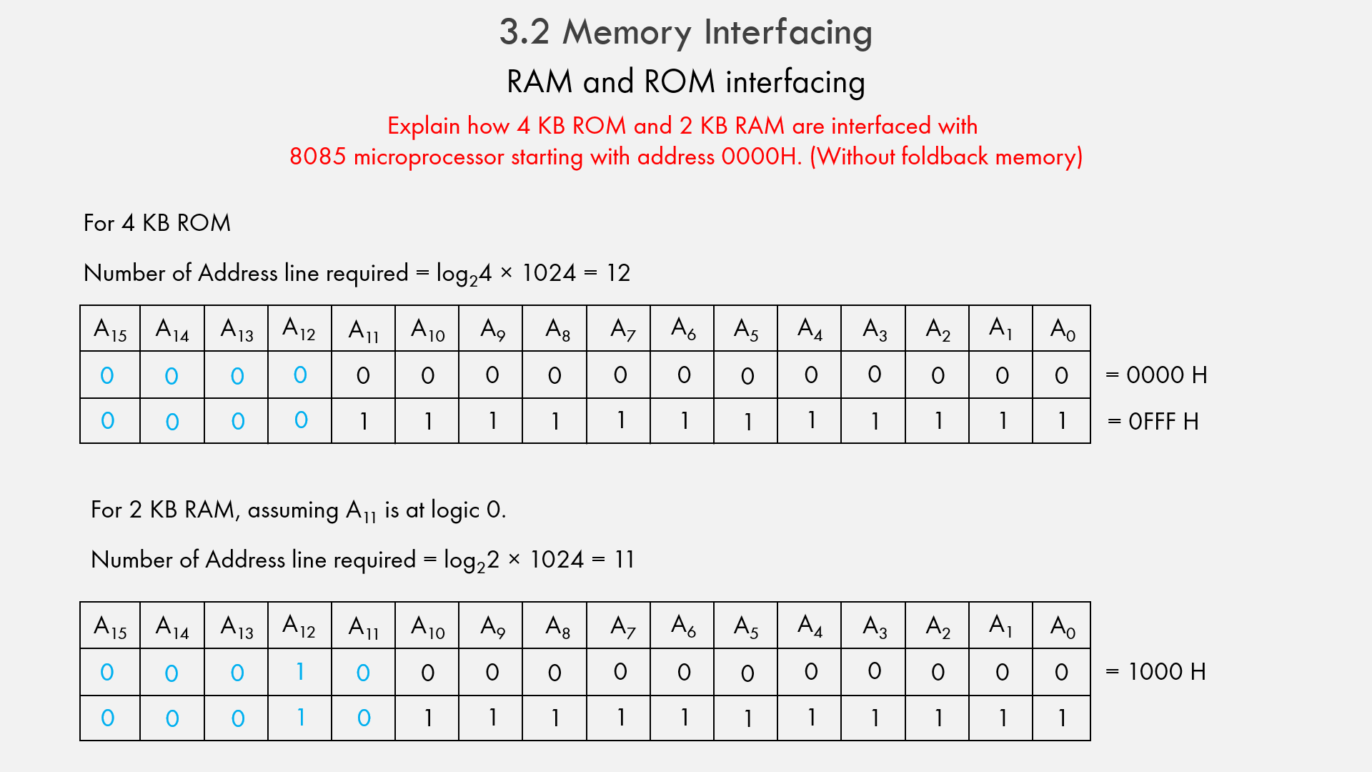
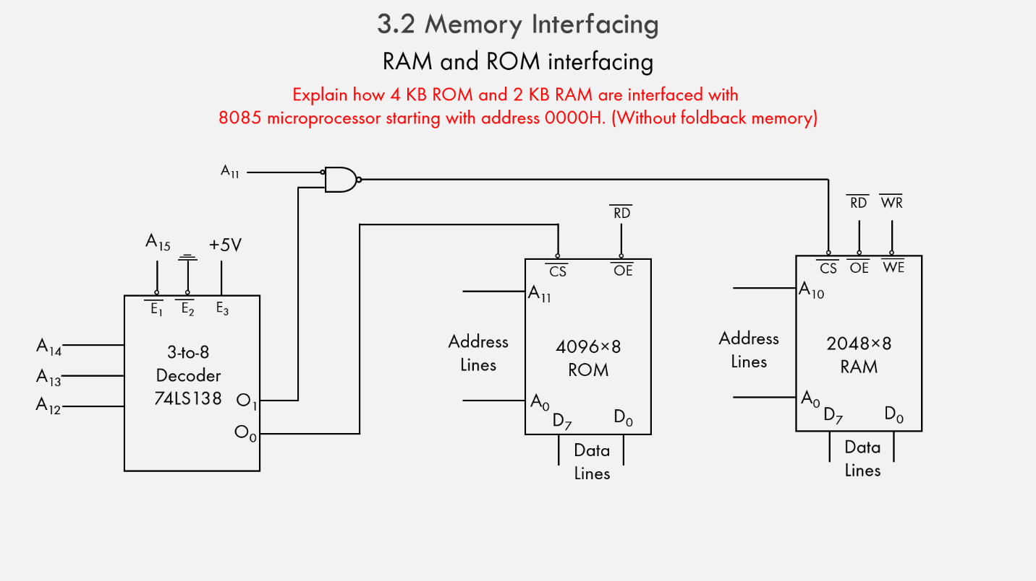

Associative Memory
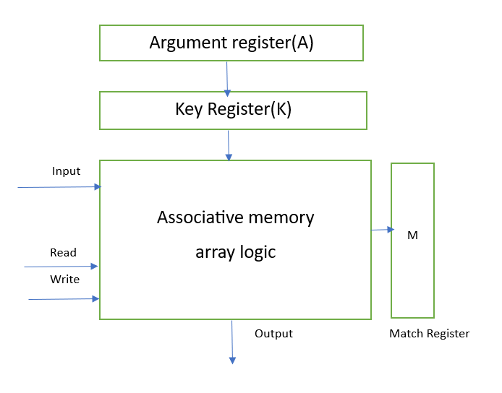
In conventional memory, data is stored in specific locations, called addresses, and retrieved by referencing those addresses. In associative memory, data is stored together with additional tags or metadata that describe its content. When a search is performed, the associative memory compares the search query with the tags of all stored data, and retrieves the data that matches the query.

Associative memory is designed to quickly find matching data, even when the search query is incomplete or imprecise. This is achieved by using parallel processing techniques, where multiple search queries can be performed simultaneously. The search is also performed in a single step, as opposed to conventional memory where multiple steps are required to locate the data.
- Argument Register: It contains words to be searched. It contains 'n' number of bits.
- Match Register: It has m-bits, One bit corresponding to each word in the memory array. After the making process, the bits corresponding to matching words in match register are set to '1'.
- Key Register: It provides a mask of choosing a particular field/key in argument register. It specifies which part of the argument word need to be compared with words in memory.
- Associative Memory Array: It combines word in that are to be compared with the arguments word in parallel. It contains 'm' words with 'n' bit per word.
Applications of Associative memory
- It can be only used in memory allocation format.
- It is widely used in the database management systems, etc.
- Networking: Associative memory is used in network routing tables to quickly find the path to a destination network based on its address.
- Image processing: Associative memory is used in image processing applications to search for specific features or patterns within an image.
- Artificial intelligence: Associative memory is used in artificial intelligence applications such as expert systems and pattern recognition.
- Database management: Associative memory can be used in database management systems to quickly retrieve data based on its content.
Advantages of Associative memory
- It is used where search time needs to be less or short.
- It is suitable for parallel searches.
- It is often used to speedup databases.
- It is used in page tables used by the virtual memory and used in neural networks.
Disadvantages of Associative memory
- It is more expensive than RAM
- Each cell must have storage capability and logical circuits for matching its content with external argument.

Cache Memory and Mapping Techniques
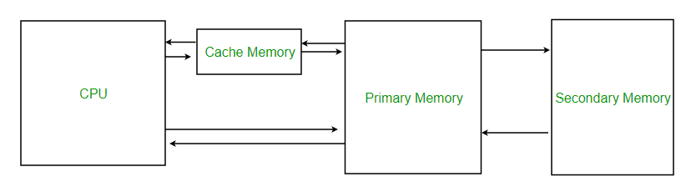
Cache Memory is a special very high-speed memory. It is used to speed up and synchronizing with high-speed CPU. Cache memory is costlier than main memory or disk memory but economical than CPU registers. Cache memory is an extremely fast memory type that acts as a buffer between RAM and the CPU. It holds frequently requested data and instructions so that they are immediately available to the CPU when needed.
Cache memory is used to reduce the average time to access data from the Main memory. The cache is a smaller and faster memory which stores copies of the data from frequently used main memory locations. There are various different independent caches in a CPU, which store instructions and data.
Levels of memory:
- Level 1 or Register
It is a type of memory in which data is stored and accepted that are immediately stored in CPU. Most commonly used register is accumulator, Program counter, address register etc.
- Level 2 or Cache memory
It is the fastest memory which has faster access time where data is temporarily stored for faster access.
- Level 3 or Main Memory
It is memory on which computer works currently. It is small in size and once power is off data no longer stays in this memory.
- Level 4 or Secondary Memory
It is external memory which is not as fast as main memory but data stays permanently in this memory.

Cache Performance
When the processor needs to read or write a location in main memory, it first checks for a corresponding entry in the cache.
- If the processor finds that the memory location is in the cache, a cache hit has occurred and data is read from cache
- If the processor does not find the memory location in the cache, a cache miss has occurred. For a cache miss, the cache allocates a new entry and copies in data from main memory, then the request is fulfilled from the contents of the cache.
The performance of cache memory is frequently measured in terms of a quantity called Hit ratio.

Hit ratio = hit / (hit + miss) = no. of hits/total accesses
We can improve Cache performance using higher cache block size, higher associativity, reduce miss rate, reduce miss penalty, and reduce the time to hit in the cache.
Cache Mapping:
There are three different types of mapping used for the purpose of cache memory which are as follows: Direct mapping, Associative mapping, and Set-Associative mapping. These are explained below.
- Direct Mapping –
The simplest technique, known as direct mapping, maps each block of main memory into only one possible cache line. In Direct mapping, assign each memory block to a specific line in the cache. If a line is previously taken up by a memory block when a new block needs to be loaded, the old block is trashed. An address space is split into two parts index field and a tag field. The cache is used to store the tag field whereas the rest is stored in the main memory. Direct mapping`s performance is directly proportional to the Hit ratio.
i = j modulo m
where
i=cache line number
j= main memory block number
m=number of lines in the cache
For purposes of cache access, each main memory address can be viewed as consisting of three fields. The least significant w bits identify a unique word or byte within a block of main memory. In most contemporary machines, the address is at the byte level. The remaining s bits specify one of the 2^{s} blocks of main memory. The cache logic interprets these s bits as a tag of s-r bits (most significant portion) and a line field of r bits. This latter field identifies one of the m=2^{r} lines of the cache.
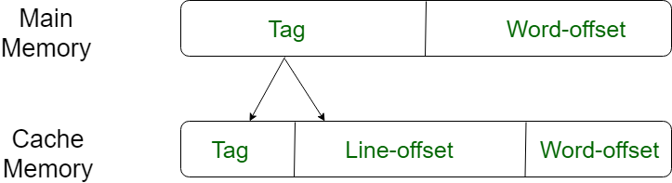
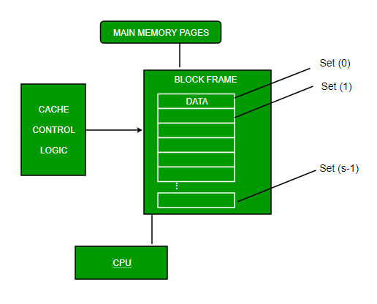
- Full Associative Mapping
In this type of mapping, the associative memory is used to store content and addresses of the memory word. Any block can go into any line of the cache. This means that the word id bits are used to identify which word in the block is needed, but the tag becomes all of the remaining bits. This enables the placement of any word at any place in the cache memory. It is considered to be the fastest and the most flexible mapping form.
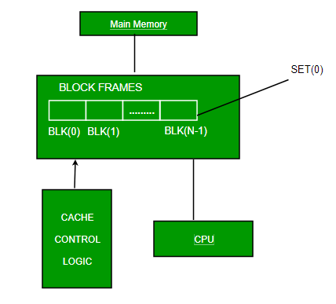
- Set-associative Mapping
This form of mapping is an enhanced form of direct mapping where the drawbacks of direct mapping are removed. Set associative addresses the problem of possible thrashing in the direct mapping method. It does this by saying that instead of having exactly one line that a block can map to in the cache, we will group a few lines together creating a set. Then a block in memory can map to any one of the lines of a specific set. Set-associative mapping allows that each word that is present in the cache can have two or more words in the main memory for the same index address. Set associative cache mapping combines the best of direct and associative cache mapping techniques.
In this case, the cache consists of a number of sets, each of which consists of a number of lines. The relationships are
m = v * k
i= j mod v

where
i=cache set number
j=main memory block number
v=number of sets
m=number of lines in the cache number of sets
k=number of lines in each set
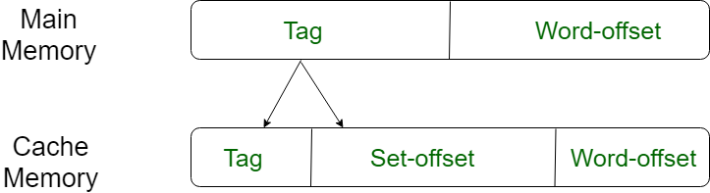
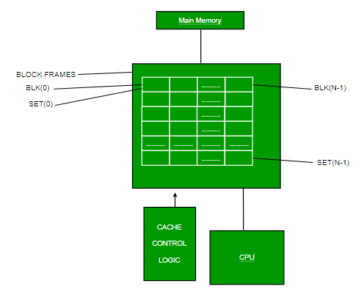
Application of Cache Memory –
  - Usually, the cache memory can store a reasonable number of blocks at any given time, but this number is small compared to the total number of blocks in the main memory.
  - The correspondence between the main memory blocks and those in the cache is specified by a mapping function.

Replacement algorithm
- When all lines are occupied, bringing in a new block requires that an existing line be overwritten.
Direct mapping
- No choice possible with direct mapping
- Each block only maps to one line
- Replace that line

Associative and Set Associative mapping
- Algorithms must be implemented in hardware for speed
- Least Recently used (LRU)
  - replace that block in the set which has been in cache longest with no reference to it
  - Implementation: with 2-way set associative, have a USE bit for each line in a set. When a block is read into cache, use the line whose USE bit is set to 0, then set its USE bit to one and the other line’s USE bit to 0.
  - Probably the most effective method
- First in first out (FIFO)
- replace that block in the set which has been in the cache longest
- Implementation: use a round-robin or circular buffer technique (keep up with which slot’s “turn” is next
- Least-frequently-used (LFU)
- replace that block in the set which has experienced the fewest references or hits
- Implementation: associate a counter with each slot and increment when used
- Random
- replace a random block in the set
- Interesting because it is only slightly inferior to algorithms based on usage

Write policy
- When a line is to be replaced, must update the original copy of the line in main memory if any addressable unit in the line has been changed
- If a block has been altered in cache, it is necessary to write it back out to main memory before replacing it with another block (writes are about 15% of memory references)
- Must not overwrite a cache block unless main memory is up to date
- I/O modules may be able to read/write directly to memory
- Multiple CPU’s may be attached to the same bus, each with their own cache
Write Through
- All write operations are made to main memory as well as to cache, so main memory is always valid
- Other CPU’s monitor traffic to main memory to update their caches when needed
- This generates substantial memory traffic and may create a bottleneck
- Anytime a word in cache is changed, it is also changed in main memory
- Both copies always agree
- Generates lots of memory writes to main memory
- Multiple CPUs can monitor main memory traffic to keep local (to CPU) cache up to date
- Lots of traffic
- Slows down writes
- Remember bogus write through caches!

Write back
- When an update occurs, an UPDATE bit associated with that slot is set, so when the block is replaced it is written back first
- During a write, only change the contents of the cache
- Update main memory only when the cache line is to be replaced
- Causes “cache coherency” problems -- different values for the contents of an address are in the cache and the main memory
- Complex circuitry to avoid this problem
- Accesses by I/O modules must occur through the cache
- Multiple caches still can become invalidated, unless some cache coherency system is used. Such systems include:
  - Bus Watching with Write Through - other caches monitor memory writes by other caches (using write through) and invalidates their own cache line if a match
  - Hardware Transparency - additional hardware links multiple caches so that writes to one cache are made to the others
  - Non-cacheable Memory - only a portion of main memory is shared by more than one processor, and it is non-cacheable

